Main article Timișoara.

Contents  - 1. Geography  - 1.1 Climate  - 2. History  - 3. Population  - 3.1. Ethnical structure  - 4. Politics  - 5. Economy  - 6. Transport  - 7. Culture | 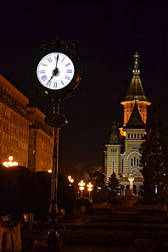

Timișoara is a city in Romania

1. Geography
1.1. Climate

Average temperature
Period | Jan | Feb | Mar | Apr | May | Jun | Jul | Aug | Sep | Oct | Nov | Dec | Annual
2006 | -1,7° | 0,0° | 5,0° | 12,4° | 16,2° | 19,5° | 23,6° | 20,1° | 17,5° | 12,5° | 6,4° | 2,1° | 11,1°
Average temperature
Period | Jan | Feb | Mar | Apr | May | Jun | Jul | Aug | Sep | Oct | Nov | Dec | Annual
2007 | -1,7° | 0,0° | 5,0° | 12,4° | 16,2° | 19,5° | 23,6° | 20,1° | 17,5° | 12,5° | 6,4° | 2,1° | 11,1°

[…]
Main article: Timișoara.

